COMPUTER PROGRAMING LAB REPORT # 3

NAME | Amin Sultan
REGISTRATION NUMBER | BF25NWELE0737
DEPARTMENT | ELECTRICAL ENG (POWER)
SECTION | “A”
SEMISTER | 1st
SUBJECT | COMPUTER PROGRAMING

1. Objective

The objective of this lab is to master decision-making in C++ by implementing:
- Relational Operators for value comparison.
- Logical Operators for combining multiple conditions.
- Decision Control Structures including if, if-else, and else-if cascades.

- Technical Theory

2.1 Relational Operators
Used to compare two values. The result is always a boolean (true or false).
- < (Less than), > (Greater than)
- <= (Less than or equal to), >= (Greater than or equal to)
- == (Equal to), != (Not equal to)
•

2.2 Logical Operators
Used to form complex conditions by combining relational expressions.
- && (Logical AND): True if both conditions are true.
- || (Logical OR): True if at least one condition is true.
- ! (Logical NOT): Reverses the logical state of its operand.
•

2.3 Decision Control Structures
By default, C++ code executes sequentially. Decision structures allow the program to skip or execute specific blocks based on conditions.
- if: Executes a block only if the condition is true.
- if-else: Provides an alternative block if the condition is false.
- else-if: Allows for multiple independent conditions to be checked in sequence.

Task 1:
Basic if Statement:
Problem: Take a number as input. If it is greater than 100, print "The number is greater than hundred".
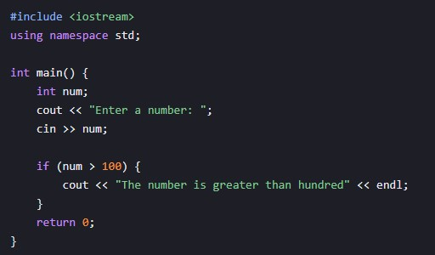
Task 2:

The if-else Statement
Problem: Take two numbers as input and subtract the larger number from the smaller one (or find the absolute difference)

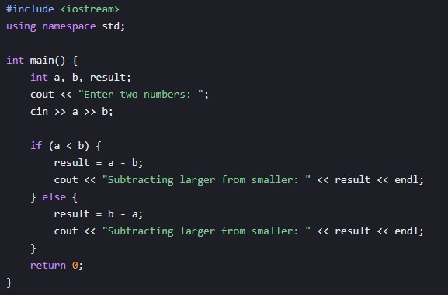
Task 3:

The else-if Statement (Multi-way Decision)
Problem: Implement a grade or category check based on multiple ranges.
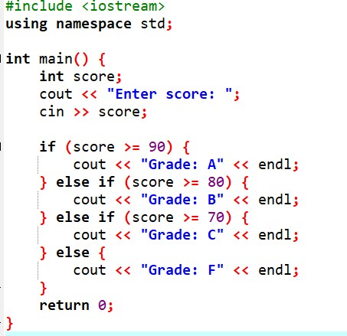

Conclusion
In this lab, we successfully implemented decision-making logic in C++. We observed that ifelse structures provide a way to handle binary choices, while the else-if ladder is essential for handling multiple mutually exclusive conditions efficiently.

